**Phase 03**

**Visualization report**

**Power bi**

1. **Time based analysis for crashes  
   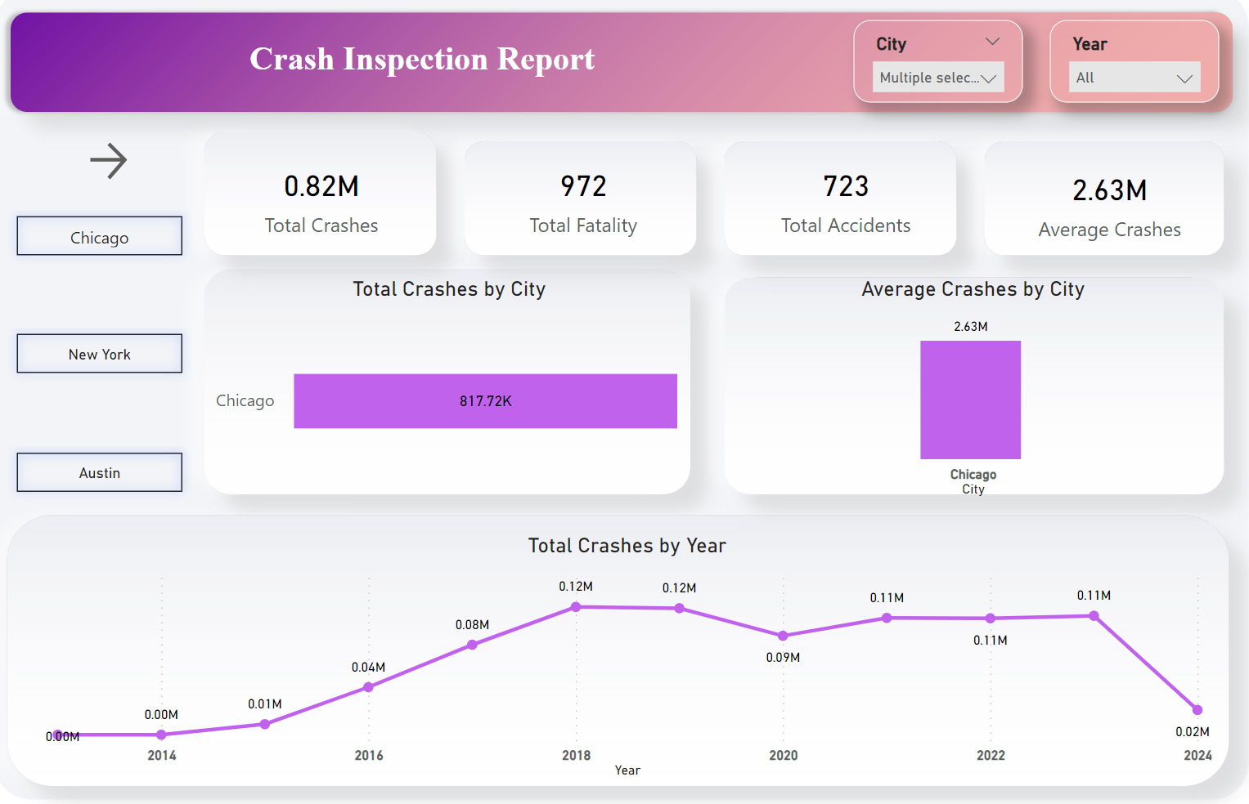**
2. **Accident Report**

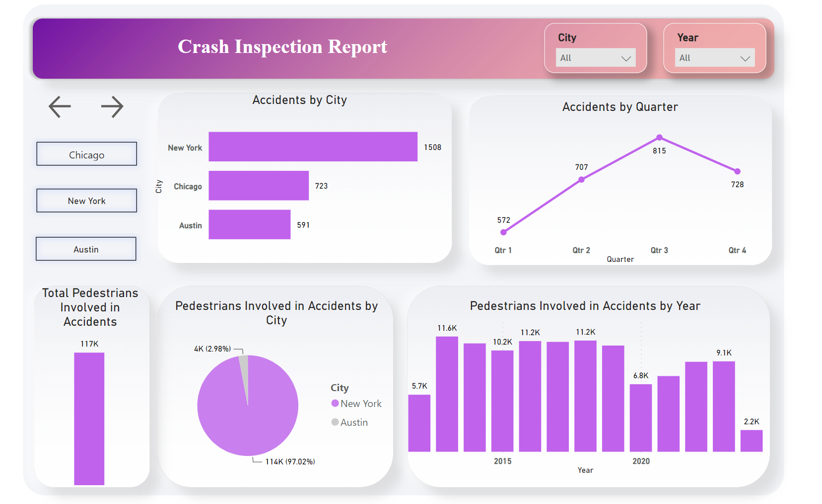

1. **Crash Analysis**

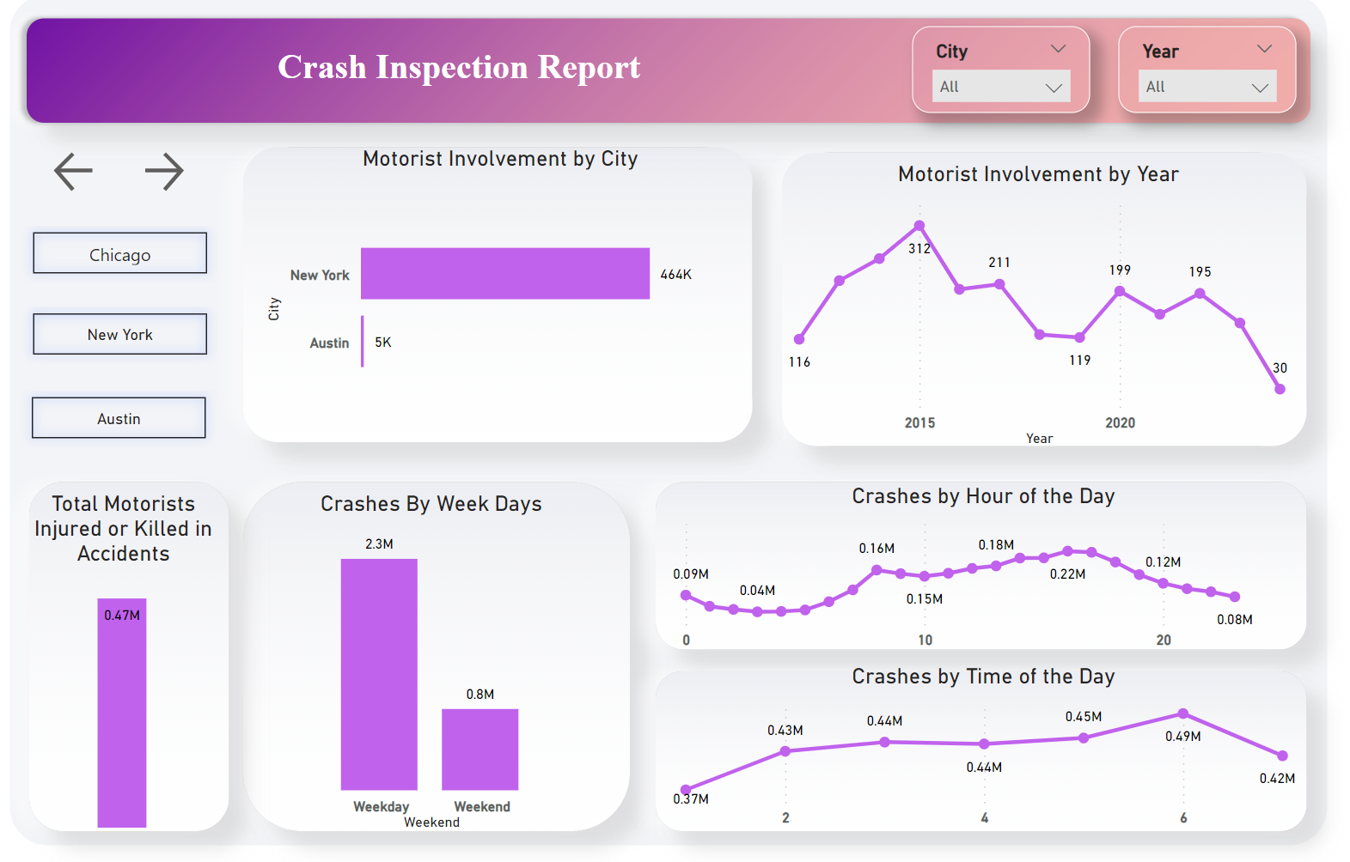

1. **Pedestrians involved in accidents (Fatality Analysis)  
   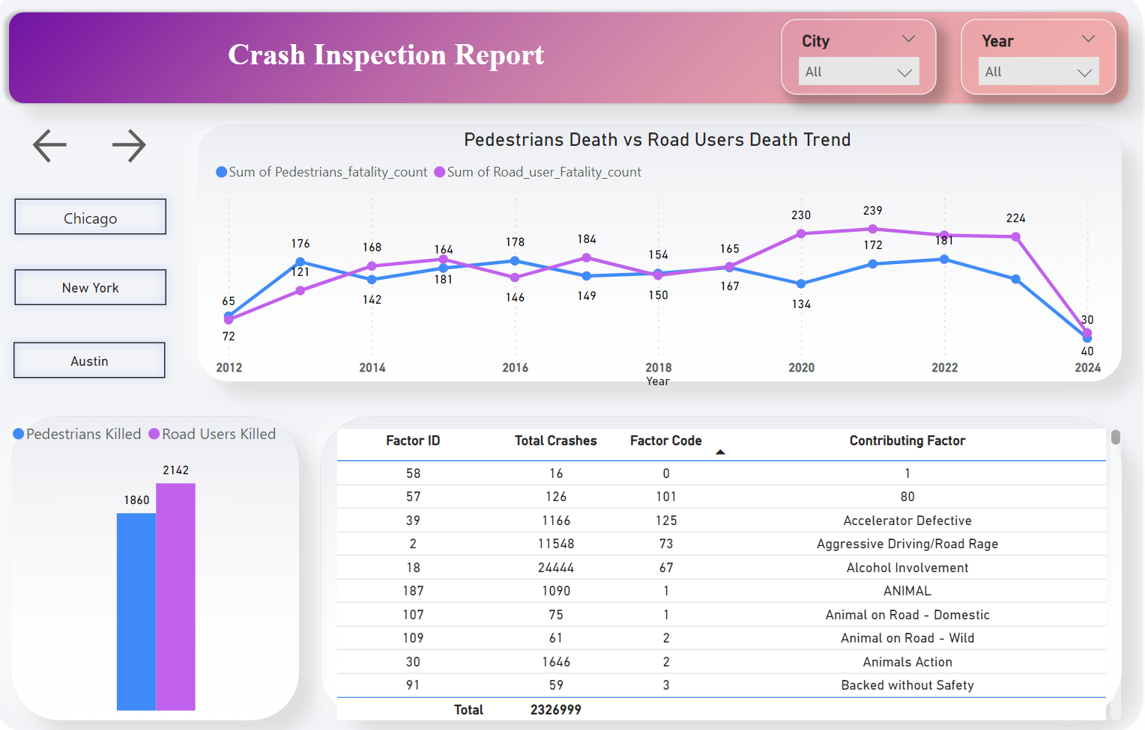**
2. **Top 10 Contributing Factor**

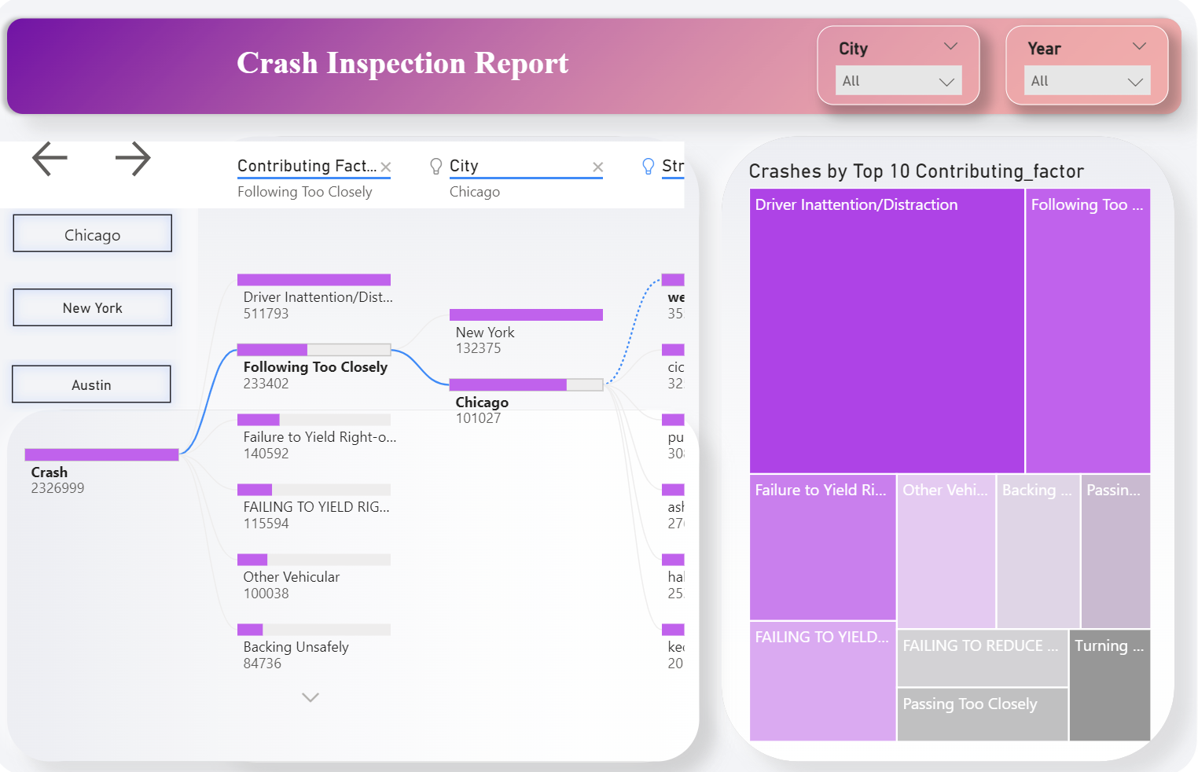

1. **Top 5 areas with most crashes**

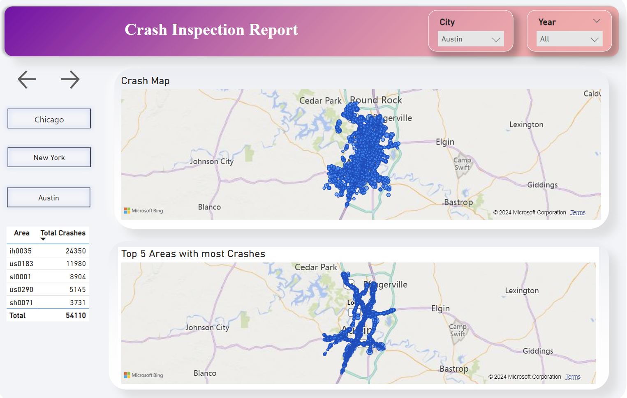

1. **Top 5 areas with most fatalities**

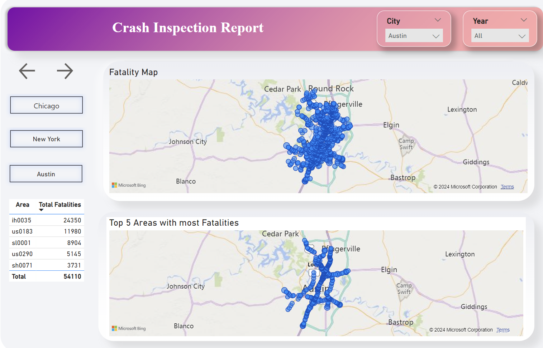

1. **Top 5 areas with most injuries**

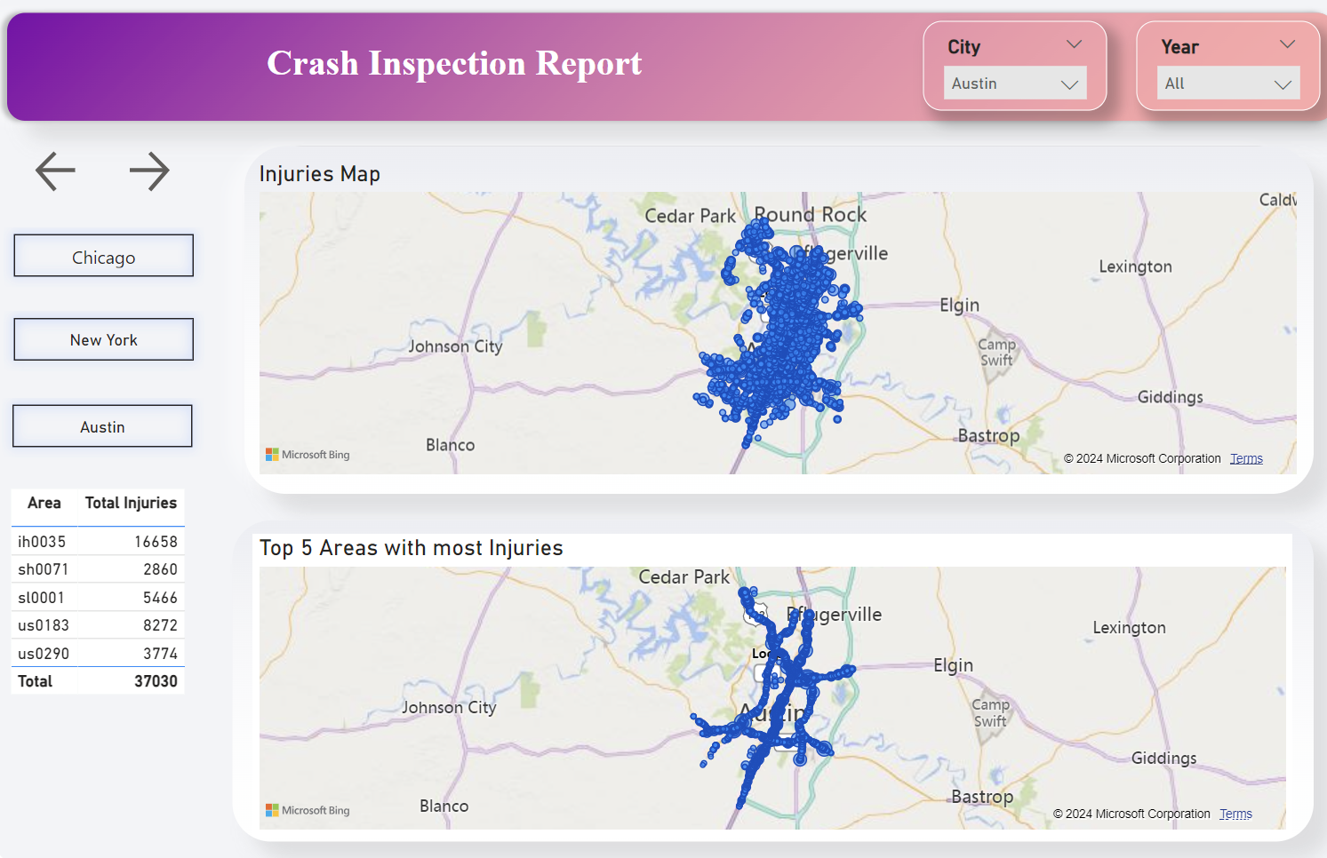

1. **Top 5 vehicles for most crashes**

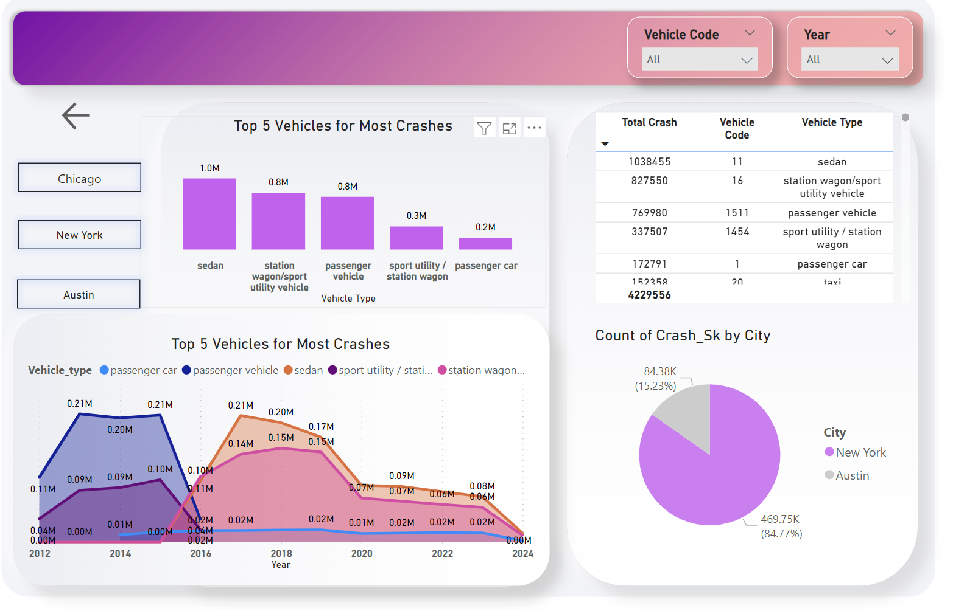

**Dashboard 1 New York   
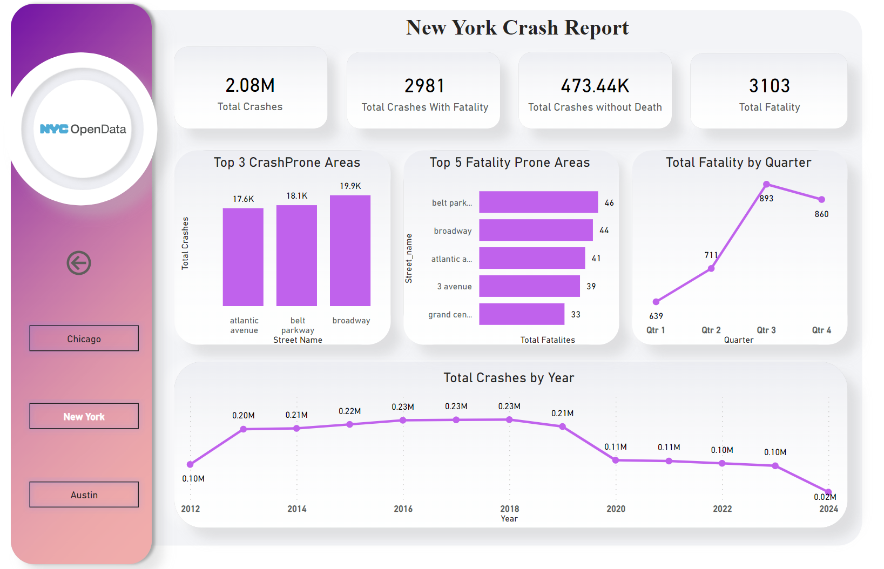**

**Dashboard 2 Austin  
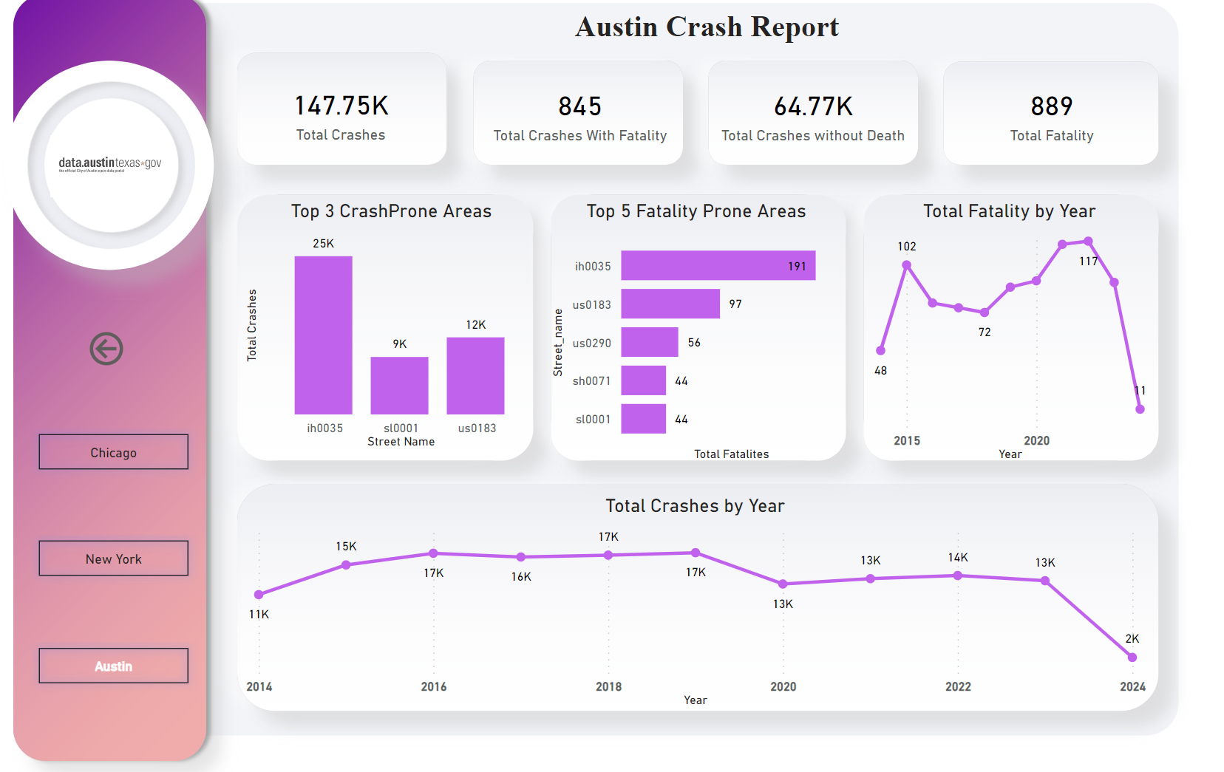**

**Dashboard 3 Chicago  
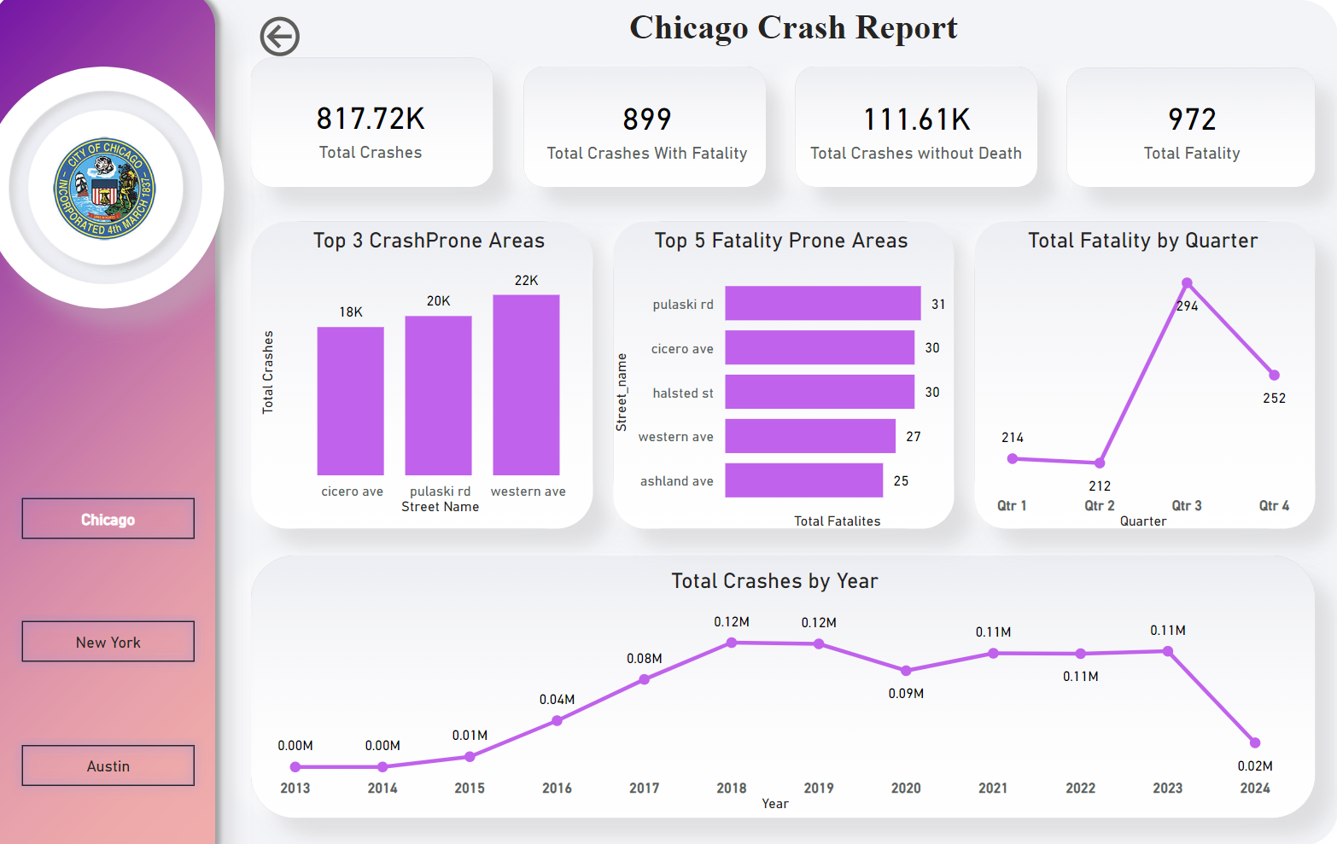**

**Tableau**

1. **Total Accidents across cities  
   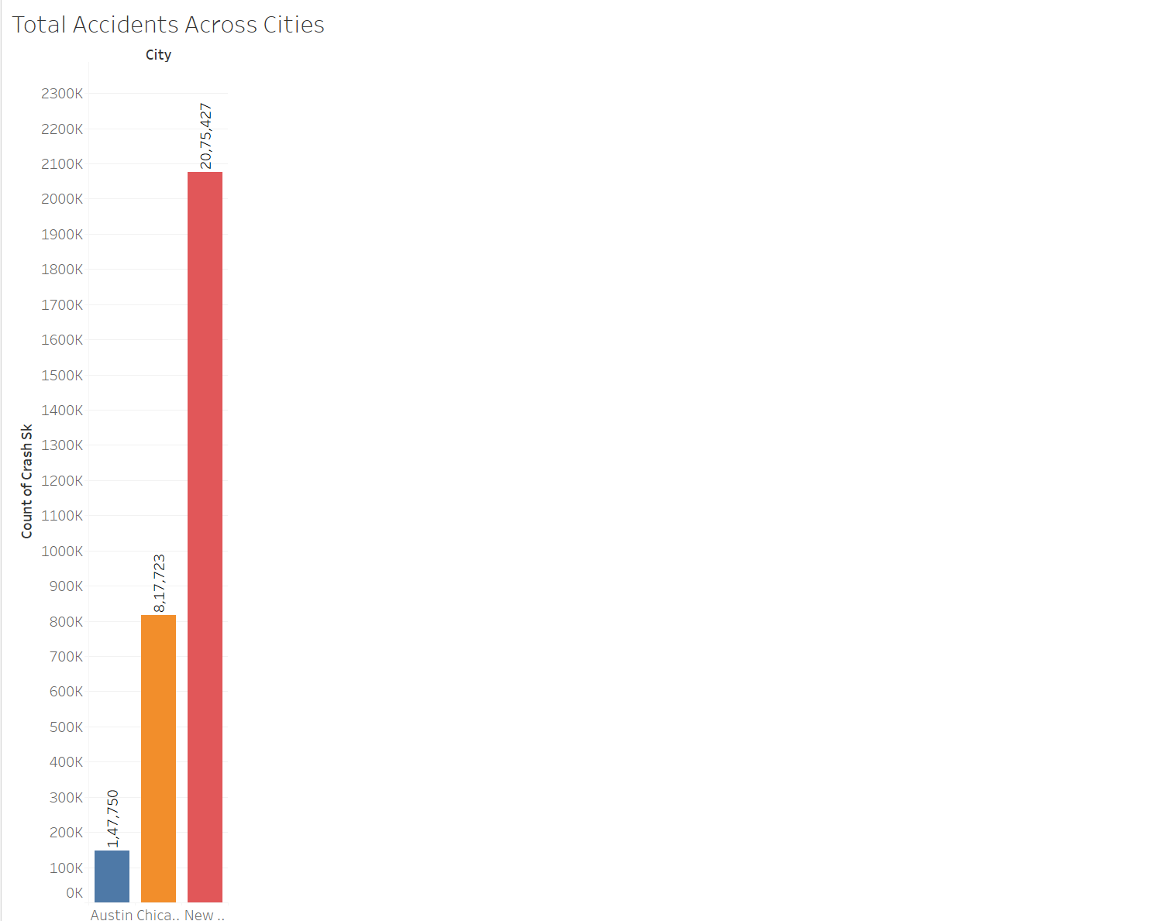**
2. **Top 3 areas with most accidents per City  
   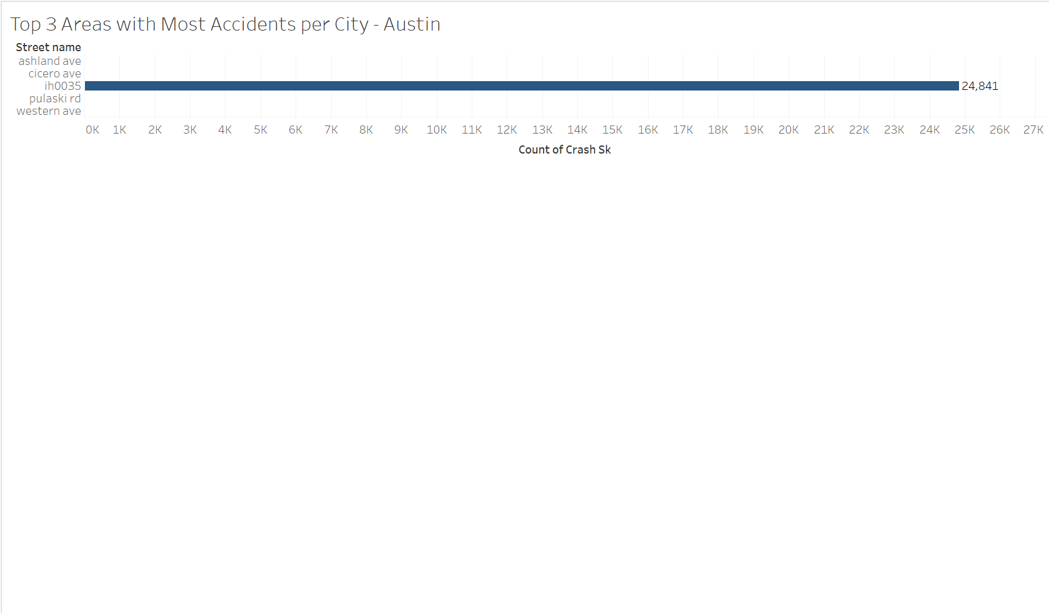**
3. **Accidents resulting in injuries by city**

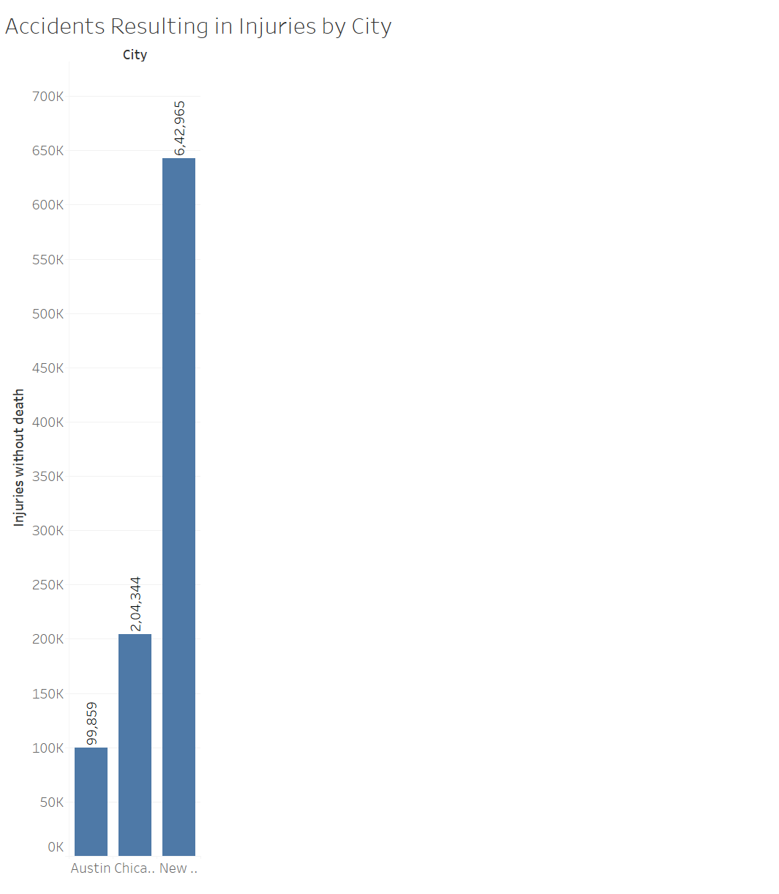

1. **Accidents resulting in injuries  
   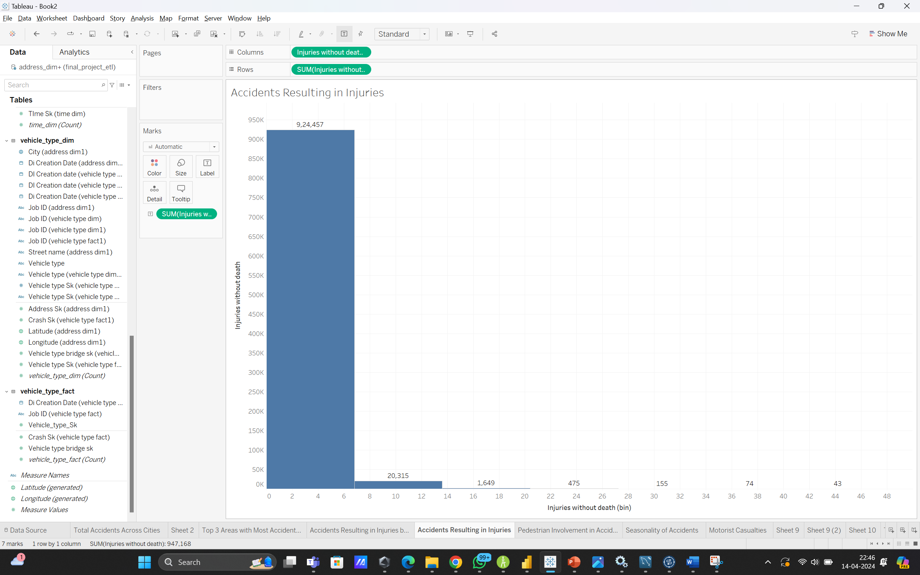**
2. **Pedestrians involved in accidents.**

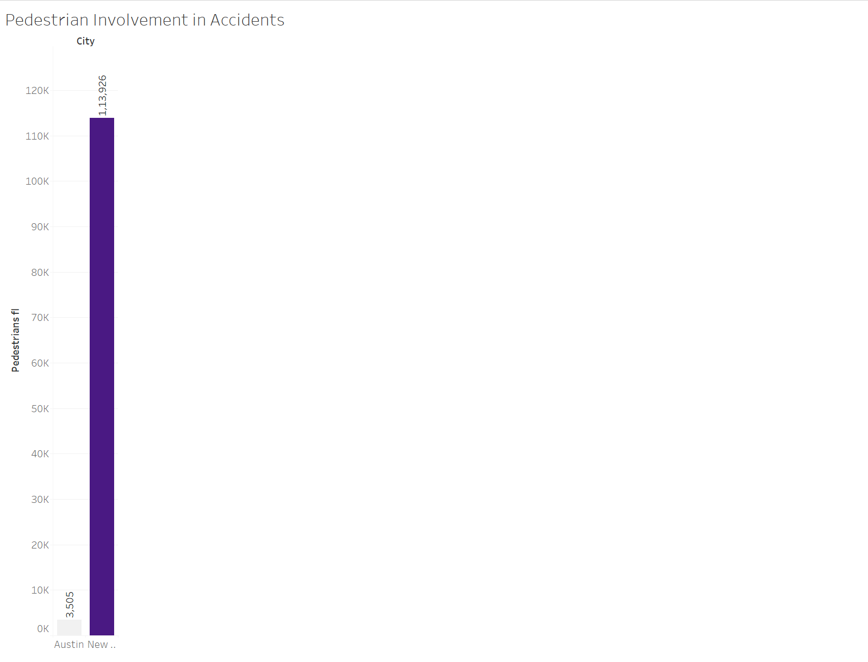

1. **Seasonality report of Accidents  
   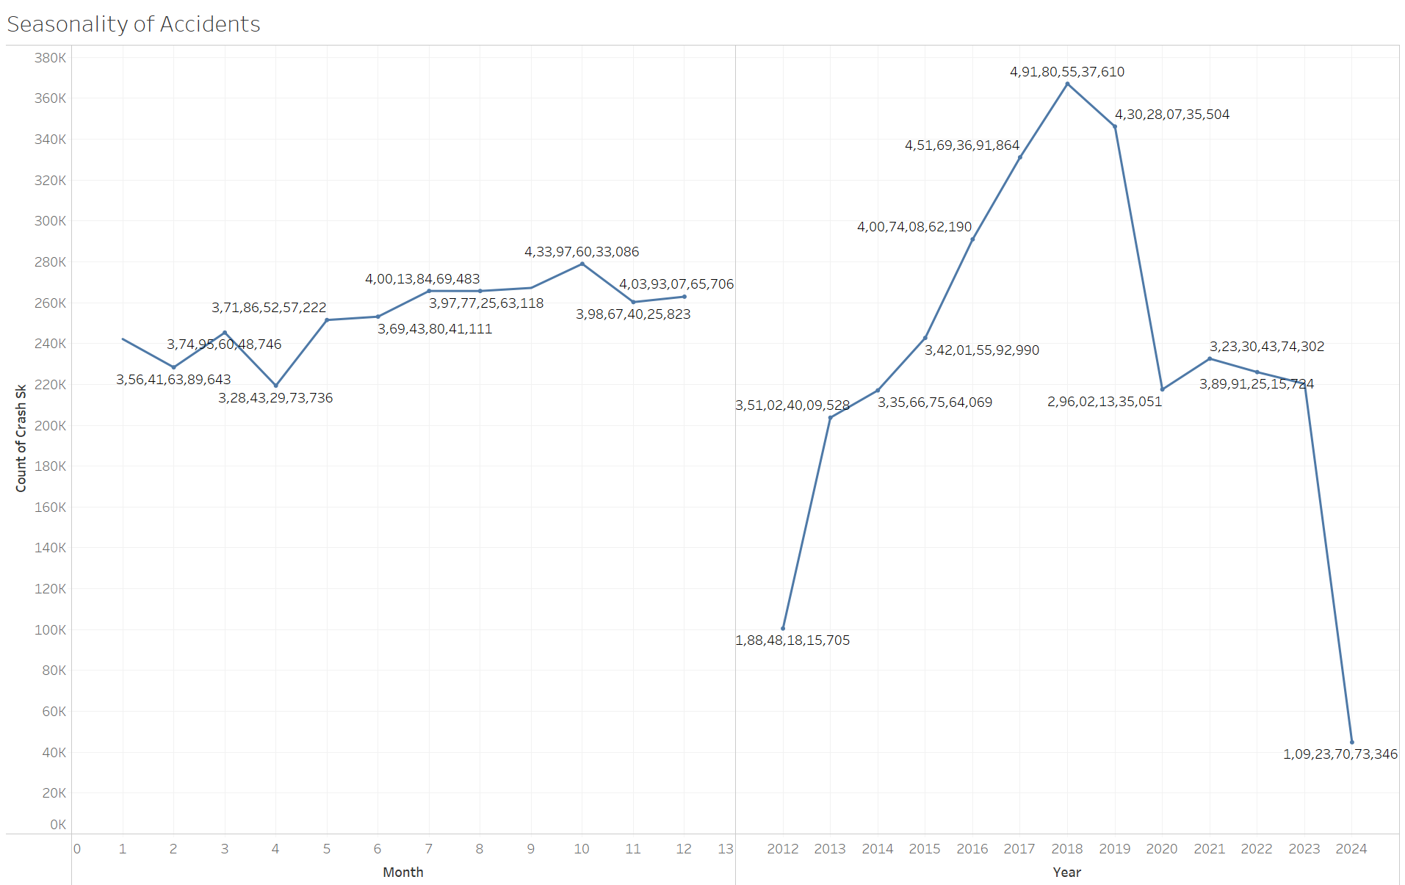**
2. **Motorists Casualities  
   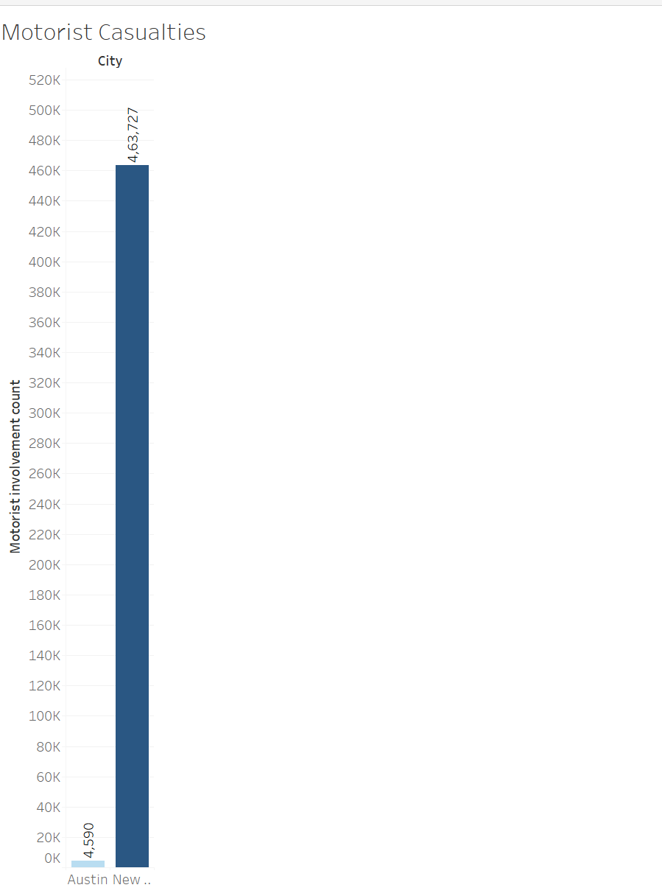**
3. **Time based analysis of accidents**

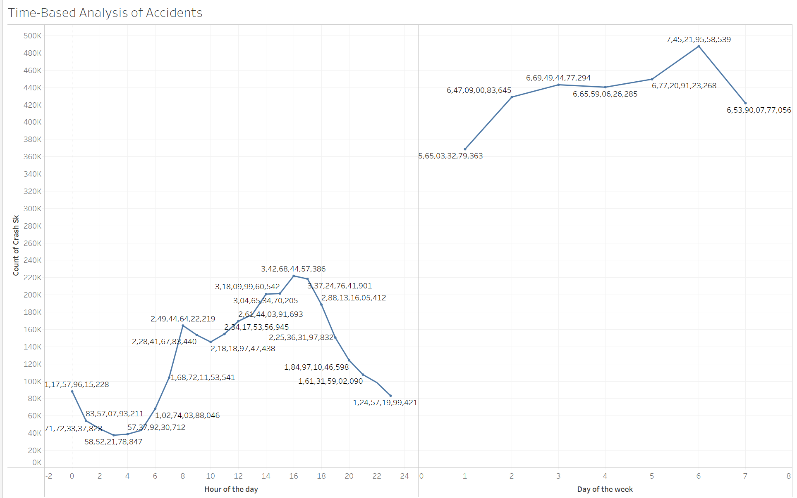

1. **Fatality Analysis**

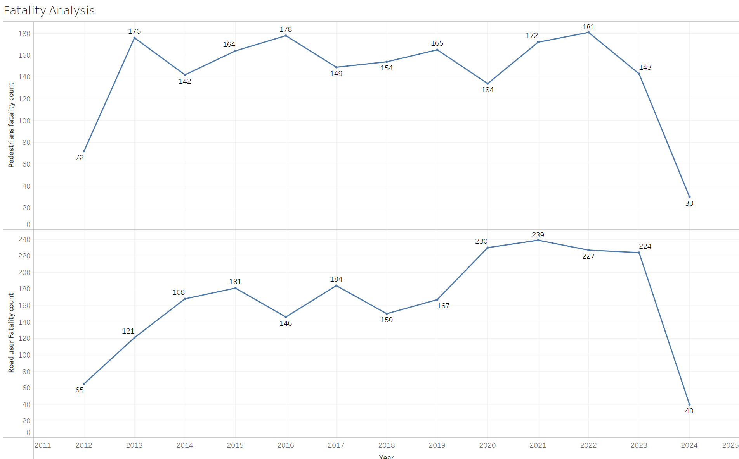

1. **Crashes and contributing factors  
   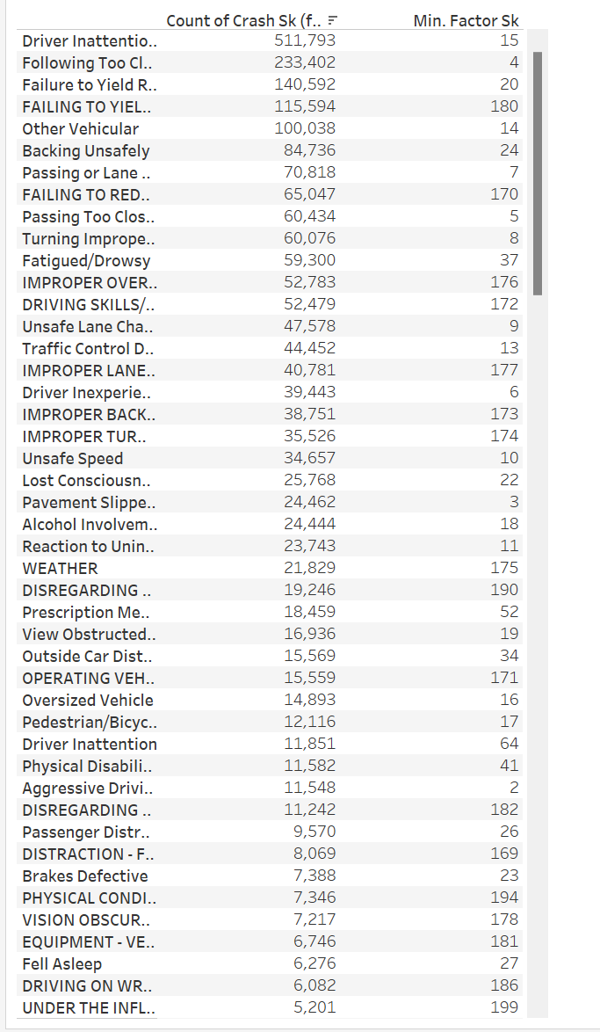**
2. **Vehicle type with count of crash  
   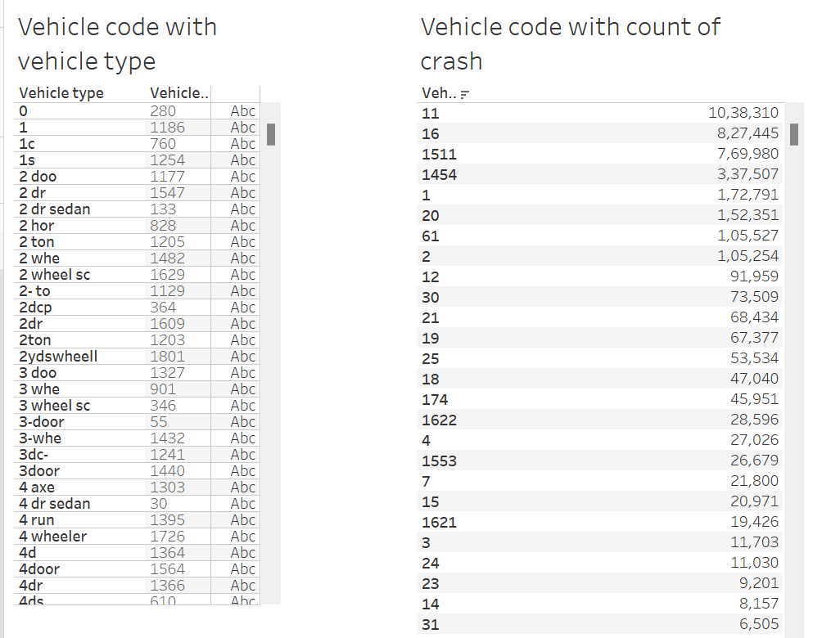**
3. **Number of vehicles involved greater than 2  
   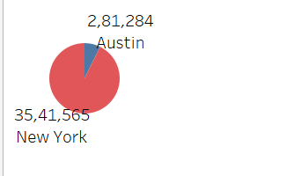**

**Contributions :**

**Saiyam : ETL, powerbi, tableau.**

**Yash: Documentation, Power bi, Tableu, Staging of tables.**

**Durgesh: Documentation, Landing of tables and tableau**

**There was no info about motorists, bicycle, pedestrians and vehicles involved and hence mentioned -1 for each of their flags in**